CIS31041 - Practical for Data Mining
Lab Sheet 05

Reg.No:-SEU.IS.20.ICT.084 Date:-

Title: Explanatory Data Analysis
Aim:
- Working with Pandas library
- Working with data visualization
Task:
- Panda library
- Import the data set
- Data visualization
- Explanatory data analysis

Exercises:

- Pandas
  - Import the pandas as pd
  - Create the series
  - Find the data type of the series
  - Print the index of the element
  - Multiply and add the element in the series
  - Print the date
  - Create the data frame
  - Insert the given data frame and explain the output
  - Find the datatype of data frame
  - Find the first few values of the data frame
  - Find the last records of the data frame
  - Index values of data frame
  - Find the column of the data frame
  - Convert the data frame into numpy array
  - Find the statistics summary of data frame
  - Transpose the data frame
  - Sort the data frame
  - Retrieve the value from the data frame

# a. Import the pandas as pd
import pandas as pd
import numpy as np

# b. Create the series
series = pd.Series([10, 20, 30, 40])
print("Series:\n", series)

# c. Find the data type of the series
print("\nData type of series:", series.dtype)

# d. Print the index of the element
print("\nIndex of the series:", series.index)

# e. Multiply and add the element in the series
print("\nSeries multiplied by 2:\n", series * 2)
print("Series after adding 5:\n", series + 5)

# f. Print the date
print("\nToday's date:", pd.Timestamp.today())

# g. Create the data frame
data = {
'Name': ['Alice', 'Bob', 'Charlie'],
'Age': [25, 30, 35],
'Salary': [50000, 60000, 70000]
}
df = pd.DataFrame(data)
print("\nDataFrame:\n", df)

# h. Insert the given data frame and explain the output
# Explanation: Each key in the dictionary becomes a column, values become rows.
print("\nInserted DataFrame (Each column is a key, rows are values):\n", df)

# i. Find the datatype of data frame
print("\nData types of each column:\n", df.dtypes)

# j. Find the first few values of the data frame
print("\nFirst 2 records:\n", df.head(2))

# k. Find the last records of the data frame
print("\nLast 2 records:\n", df.tail(2))

# l. Index values of data frame
print("\nIndex of DataFrame:", df.index)

# m. Find the column of the data frame
print("\nColumns of DataFrame:", df.columns)

# n. Convert the data frame into numpy array
print("\nDataFrame as NumPy array:\n", df.to_numpy())

# o. Find the statistics summary of data frame
print("\nStatistics Summary:\n", df.describe())

# p. Transpose the data frame
print("\nTransposed DataFrame:\n", df.T)

# q. Sort the data frame (by Age)
print("\nDataFrame sorted by Age:\n", df.sort_values(by='Age'))

# r. Retrieve the value from the data frame (e.g., Age of second person)
print("\nAge of second person (Bob):", df.loc[1, 'Age'])

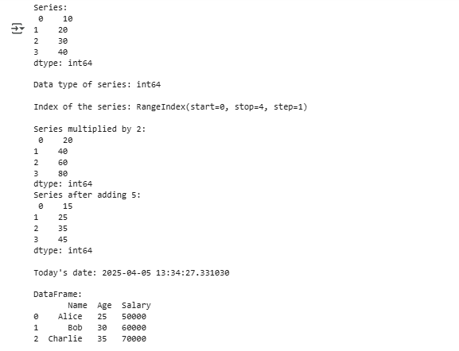

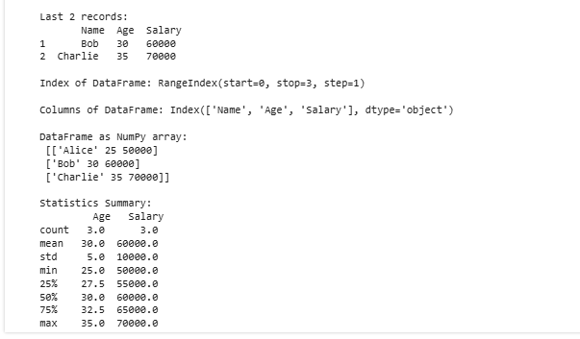
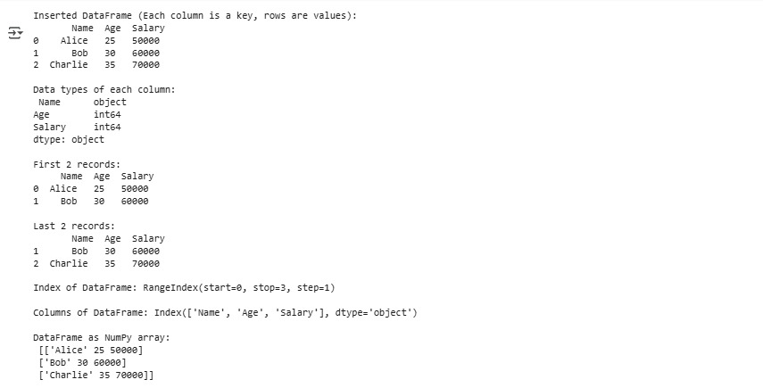

- Import the data set
  - Filter the first five records of the data set heart.csv
  - Find the data type of attributes
  - Find the information of data set
  - Find the summary statistics of the data set
  - Retrieve the information cp greater than 2

# Import pandas
import pandas as pd

# 02. Import the data set
df = pd.read_csv('heart.csv') # Make sure heart.csv is in the same directory

# a. Filter the first five records of the data set
print("First 5 Records:\n", df.head())

# b. Find the data type of attributes
print("\nData Types:\n", df.dtypes)

# c. Find the information of data set
print("\nDataFrame Info:")
df.info()

# d. Find the summary statistics of the data set
print("\nSummary Statistics:\n", df.describe())

# e. Retrieve the information where cp > 2
print("\nRecords where 'cp' > 2:\n", df[df['cp'] > 2])
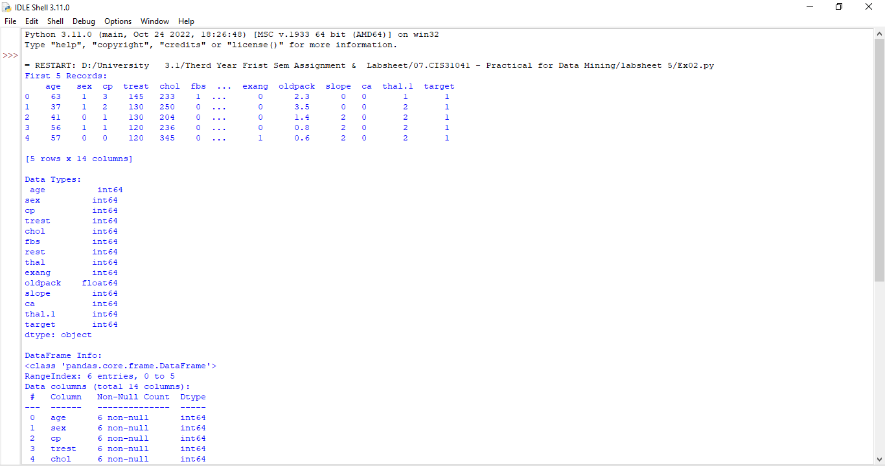

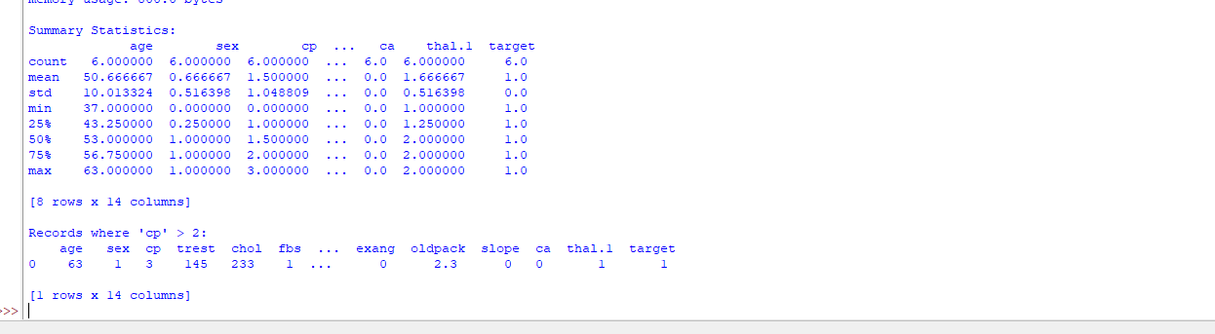

- Data visualization
  - import the bank-data.csv file
  - Retrieve the first five records in the data set
  - Plot the data set
  - Describe the data set
  - Plot the data set income Vs children
  - Construct the bar chart for region
  - Construct the scatter plot for income and children and set the title as income vs children
  - Construct the histogram for children

# Import necessary libraries
import pandas as pd
import matplotlib.pyplot as plt
import seaborn as sns

# a. Import the bank-data.csv file
df = pd.read_csv('bank-data.csv') # Ensure the file is located correctly or provide the full path

# b. Retrieve the first five records in the data set
print("First 5 Records:\n", df.head())

# c. Plot the data set (For example, a pairplot for the numerical columns)
print("\nPlotting Pairplot for the dataset:")
sns.pairplot(df)
plt.show()

# d. Describe the data set
print("\nDataset Description:\n", df.describe())

# e. Plot the data set income vs children
plt.figure(figsize=(8, 6))
sns.scatterplot(x='income', y='children', data=df)
plt.title('Income vs Children')
plt.xlabel('Income')
plt.ylabel('Children')
plt.show()

# f. Construct the bar chart for region
plt.figure(figsize=(8, 6))
sns.countplot(x='region', data=df)
plt.title('Bar chart for Region')
plt.xlabel('Region')
plt.ylabel('Count')
plt.show()

# g. Construct the scatter plot for income and children with title
plt.figure(figsize=(8, 6))
sns.scatterplot(x='income', y='children', data=df)
plt.title('Income vs Children')
plt.xlabel('Income')
plt.ylabel('Children')
plt.show()

# h. Construct the histogram for children
plt.figure(figsize=(8, 6))
sns.histplot(df['children'], bins=10, kde=True)
plt.title('Histogram for Children')
plt.xlabel('Number of Children')
plt.ylabel('Frequency')
plt.show()

- Explanatory data analysis
  - Import the libraries numpy, pandas, matplotlin.pyplot, seaborn
  - Import the data set bank-data.csv as data
  - Check the data type
  - Check the data shape
  - Check the attribute name of the data set
  - Check the null values
  - Remove the unwanted attribute
  - Rename the Attribute name
  - Construct the plot for pep
  - Group the data sex and pep according to the count
  - Construct the graph for pep vs sex
  - Find the count of the attribute children according to the category
  - Construct the graph for attribute children according to the category
  - Construct the chart to illustrate pep, children and sex of the customer based on the count

Make sure the libraries NumPy, Pandas, Matplotlib, and Seaborn are installed:
pip install numpy pandas matplotlib seaborn

# a. Import the necessary libraries
import numpy as np
import pandas as pd
import matplotlib.pyplot as plt
import seaborn as sns

# b. Import the dataset bank-data.csv as data
data = pd.read_csv('bank-data.csv') # Ensure the file is in the correct path

# c. Check the data type
print("\nData Types:\n", data.dtypes)

# d. Check the data shape
print("\nData Shape:", data.shape)

# e. Check the attribute name of the dataset
print("\nAttribute Names:\n", data.columns)

# f. Check for the null values
print("\nNull Values:\n", data.isnull().sum())

# g. Remove unwanted attributes (example: 'unwanted_column' can be replaced with actual unwanted columns)
# Example: data = data.drop(columns=['unwanted_column'])
# data = data.drop(columns=['unwanted_column'])

# h. Rename the attribute name (example: renaming 'old_name' to 'new_name')
# Example: data.rename(columns={'old_name': 'new_name'}, inplace=True)

# i. Construct the plot for pep (assuming pep is a column in the dataset)
# Let's plot the distribution of the 'pep' column
plt.figure(figsize=(8, 6))
sns.countplot(x='pep', data=data)
plt.title('Distribution of pep')
plt.xlabel('PEP')
plt.ylabel('Count')
plt.show()

# j. Group the data by 'sex' and 'pep' according to the count
grouped_data = data.groupby(['sex', 'pep']).size().reset_index(name='count')
print("\nGrouped Data (sex and pep count):\n", grouped_data)

# k. Construct the graph for pep vs sex
plt.figure(figsize=(8, 6))
sns.countplot(x='sex', hue='pep', data=data)
plt.title('PEP vs Sex')
plt.xlabel('Sex')
plt.ylabel('Count')
plt.show()

# l. Find the count of the attribute children according to the category
children_count = data['children'].value_counts().reset_index()
children_count.columns = ['Children', 'Count']
print("\nChildren Count:\n", children_count)

# m. Construct the graph for the attribute children according to the category
plt.figure(figsize=(8, 6))
sns.countplot(x='children', data=data)
plt.title('Distribution of Children')
plt.xlabel('Number of Children')
plt.ylabel('Count')
plt.show()

# n. Construct the chart to illustrate pep, children, and sex of the customer based on the count
plt.figure(figsize=(8, 6))
sns.countplot(x='children', hue='pep', data=data)
plt.title('PEP, Children, and Sex Distribution')
plt.xlabel('Number of Children')
plt.ylabel('Count')
plt.show()

